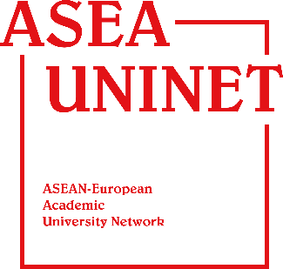


REGISTRATION FORM
ASEA UNINET Students Week 2017
“Sustainable Development: A Multidisciplinary Approach”
Universitas Indonesia, December 3—16, 2017

Personal Details
1
Please provide your information details as they appear in your passport.
Mr. /Mrs. /Ms. *
Salutation : *delete the inappropriate options

Full Name*

Current Email Address*
Phone Number*

Please include Country Code. Example: +123XXXXXX

Current mailing address :

City

Country Postal Code
DD / MM/ YYYY
Date of Birth

Nationality

Gender

Passport Number

Issuing Country

Date of Issue Date of Expiry

Home University
2

Name of University

Faculty Name :

Major/Dept Name

Mailing Address

City Country
Postal Code

Faculty/ International Office Contact person*

E-mail address*

Phone number*

Please include Country Code. Example: +123XXXXXX
3
Ho Program Information

Program Duration
2 weeks
Program Credits: 3 credits

Offered Course
Sustainable Development with Multidisciplinary Approach

Arrival Information
Airlines name & Flight number:
Date: Time:

Departure Information
Airlines name & Flight number:
Date: Time:

4
Checklist for Submitted Document

- Completed Application Form
- Resume/CV
- Letter of Recommendation issued by home university
- Copy of Passport
- Certificate of English Proficiency (TOEFL/IELTS/TOEIC/etc)
- Recommendation Letter from home university

DD/MM/YY
Applicant’s Signature: Date:

